The Ministry of Education and Science of the Russian Federation
National Research
Tomsk State University

Geology and Geography Faculty

Russian Geographical Society, Tomsk branch
Russian Geological Society, Tomsk branch

IV Russian Scientific and Practical Conference
with International Participation
«Modern problems of geography and geology»,
dedicated to the 100th anniversary of the foundation of the natural department of the Tomsk State University
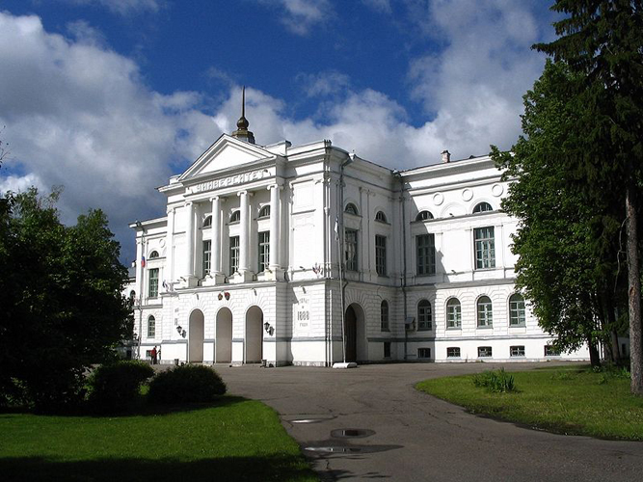
Tomsk, 16–19 October 2017

Information letter
Dear Colleagues!
We are pleased to invite you to take part in the IV Russian scientific and practical conference with international participation "Modern problems of geography and geology" from 16th to 19th of October in 2017. The conference aims to unite scientists and experts in the field of geography, geology and related sciences for the dissemination of best scientific and practical experience, as well as for the formation of a scientific culture of young researchers.
On 3 August 1888, there was the official opening of the Tomsk University - the first university in Siberia. As part of a single medical faculty there were formed departments of mineralogy and geology; physics, physical geography and meteorology; botany and zoology. In 1917, on the basis of these and other departments there was organized the natural department of Tomsk State University, which was the forerunner of all existing natural sciences faculties and departments of TSU. This Conference is dedicated to the 100th anniversary of the foundation of the natural department of the Tomsk State University.
During the Conference there are scheduled Workshop for students, graduate students and young scientists with the participation of leading scientists and experts in various fields of geography and geology, Breakout Sessions and a Poster Session. Conference languages are Russian and English. Scientists, experts, university professors and school teachers, graduate students, undergraduates, students and schoolchildren are invited to participate in the Conference. The competition for the best scientific report will be organized among the young participants of the Conference (up to 35 years).

THE MAIN DIRECTIONS OF THE CONFERENCE
- Fundamental and applied matters of Geography
- Climatology and Glaciology of Siberia
- Hydrology of Siberia
- Potential for Regional Studies and Tourism in Siberian region and adjacent territories
- Environmental management
- Historical and Regional Geology
- Geology and Geochemistry of mineral deposits
- Scientific projects of schoolchildren

The number of sections in the directions and their themes will be determined in the second information message based on the content of received applications.

FORMS OF PARTICIPATION IN THE CONFERENCE:
  - Report on the plenary session
  - Report on the breakout session
  - Poster Report
  - Participation in absentia
Important dates
Those who wish to participate in the conference should:
before 30 March 2017 fill the registration form of the conference participant on the website
http://ggf.tsu.ru/content/faculty/structure/chair/geography/konferentsiya-2017/registratsiya/
before 10 May 2017 send by email to geo100-tsu@yandex.ru an archive file named according to the surname of the first author:
- text of the article (with embedded pictures, tables, diagrams, etc.);
- illustrations as separate files in JPG format, resolution at least 300 dpi;
- agreement to the publication and including to the database of Russian Citation Index;
- copy of the payment of the registration fee.

From each author it is acceptably only one article (individually) and one co-authored.
Materials submitted after the deadline may not be included in the conference proceedings.
Attention! Materials on paper do not need to provide!
conference proceedings
By the beginning of the Conference it is planned to publish the conference proceedings which will be included to the database of Russian Citation Index. Reports of the Conference Participants with volume from two to four full pages and meeting the requirements (specified below) will be posted on the conference website.
The Organizing Committee reserves the right to edit the scientific content, check for plagiarism and select the articles! Materials that do not meet the key thematic directions of the Conference and with non-compliance of the requirements can be rejected with notification of the author.

Contacts
Address: 634050, Tomsk, Lenina St., 36. National Research Tomsk State University. Geology and Geography Faculty. Department of Geography. Phone: +7(3822)420800
If you have any questions, please contact by email geo100-tsu@yandex.ru or on the forum of the group "Department of Geography" https://vk.com/geography_tsu
Information about the Conference is also available on the website of the Geology and Geography Faculty of TSU:
http://ggf.tsu.ru/content/faculty/structure/chair/geography/konferentsiya-2017/

Registration FEE
Fee for participation in the Conference:
- for schoolchildren - free of charge;
- for postgraduate and undergraduate students – 200 rubles per page of text;
- for other participants – 300 rubles per page of text.
- Participants in absentia pay 50% of the registration fee.

Payment of the registration fee can be done:
- remittance on the Russian Sberbank card number 4276 6404 4946 1104 (a copy of the receipt of registration fee payment must be send to the email address of the organizing committee). When conducting transactions via Sberbank Online in a text message (for SMS) the Name and purpose of payment must be indicated. For example, Ivanov II for conference;
- bank transfer to the following requisites:
Surname, Name of account owner: Kashiro Margarita Aleksandrovna
Account number: 40817810164000688497
Bank: Sberbank of Russia, Tomsk branch № 8616 PAO Sberbank, Tomsk
BIK: 046902606
Correspondent account: 30101810800000000606
KPP: 701702003
INN: 7707083893
(a copy of the receipt of registration fee payment must be send to the email address of the organizing committee).

The registration fee includes conference pack party, coffee breaks, and costs of editorial work with the conference proceedings.

GENERAL REQUIREMENTS TO THE MATERIALS
- Text volume is not more than 4 full pages of A4 format, including figures, tables, references and abstracts.
- File format - Microsoft Word version 2003 or above (DOC, DOCX).
- The page size - A4. Fields: top, bottom, left, right - 2 cm. Font - Times New Roman (size 12). Interval - single. Width adjustment. Indentation - 1 cm. Indentation of a paragraph with tabs or spaces is not allowed.
- The UDC must be indicated in the upper left corner before the title of the article. The next line contains the name of the article - in capital letters, font - bold, without division, centered. On the next line - name and initials of the author (s), lower case letters, italics, centered. On the next line, the name of the organization and the city - in lower case letters, italics, centered. After the interval, there must be a brief summary (2-3 sentences) and keywords (3-5) - normal font, justification, indentation 1 cm.
- After the interval, there must be a main text. Illustrations (figures, tables, graphs, diagrams, etc.) must be inserted into the text. Graphic illustrations (drawings, figures, photographs, scanned images, etc.) must be in JPG format with a resolution at least 300 dpi. Requirements for the caption (see the sample.): the name and number of illustration must be indicated under the illustration - normal font, size 11, centered, without hyphenation and indentation; the name and number of tables - over the tables, centered, font size 11, normal font. The tables and figures should be cited in the text: (Fig. 1) and (Table 1).
It is not allowed to use tabs, set other paragraph styles than the default, set automatic lists (or automatic line numbering and paragraphs). Only one type of quotation marks is recommended to use (« »). It is necessary to distinguish between a hyphen (-) and a dash (-). Dash can be inserted via the menu "Insert - Symbol - Plain Text." A comma (not a point) must be used when writing decimals. All abbreviations should be explained before.
When creating formulas, graphs and charts it may be only used the programs similar version of Microsoft Word 2003 and above (for example, Equation 3.0, etc.) with the same font as the main text of the article. Parameters index and special characters set automatically. It is not allowed set of Greek characters in the formulas in italics.
- Used sources are indicated at the end of the text under the heading: References. A list of sources is issued in alphabetical order and shall conform to the sample (see below). References in the main text must be in square brackets [1].
A sample:

UDC 911.5
STUDY OF ENVIRONMENTAL PROBLEMS IN THE VALLEYS OF LARGE RIVERS USING GIS AND REMOTE SENSING DATA
Khromykh V.V., Khromykh O.V.
National Research Tomsk State University, Tomsk

Abstract. This article analyzes the anthropogenic dynamics of Tom valley landscapes near Tomsk using modern GIS and remote sensing technologies. Methods of large-scale GIS-mapping of the valley geosystems are developed and tested. Examples of computer modeling are shown to identify the anthropogenic changes of landscape systems and assessment of the situation in emergencies.
Key words: Landscape dynamics, Tom valley, GIS-Mapping, Spatial analysis, Digital elevation model.

The study of the natural complexes in large river valleys and riparian zones has both theoretical and practical importance. In these valleys, which are often crossing different landscape zones, there is an expressive specific nature of the landscapes structure. On the other hand, river valleys are the most cultivated areas. The Tom river valley is characterized by complex landscape structure, which is conditioned by its location in a transition zone from the Altay Mountain Region to the Western-Siberian Platform (Fig. 1). The landscape systems of the valley have high rate of the natural transformations. Besides, a lot of landscape systems have undergone serious anthropogenic modification (Table 1). Particular intensive changes of the geosystems in the Tom River valley are observed from the middle of the XX century due to the increased industrial and agricultural activity such as sand and gravel extraction from the bed of the river, draining and melioration as well as plough-lands. Other important factors modifying the landscape are transport construction and expansion of the urban and rural areas [1].

References
1. Khromykh O.V., Khromykh V.V. The landscape Analysis of Tom valley based on GIS: natural dynamics of valley geosystems and their changes in consequence of anthropogenic impact. Tomsk: NTL, 2011. 160 p.
2. Geographic Collegiate Dictionary: Geographical names. Мoscow, 1983. 528 p.
3. Lin D. Phytotoxicity of nanoparticles: inhibition of seed germination // Environmental Pollutants. 2007. Vol. 150. P. 243−250.

Table 1

Mass fraction of heavy metals in soil samples

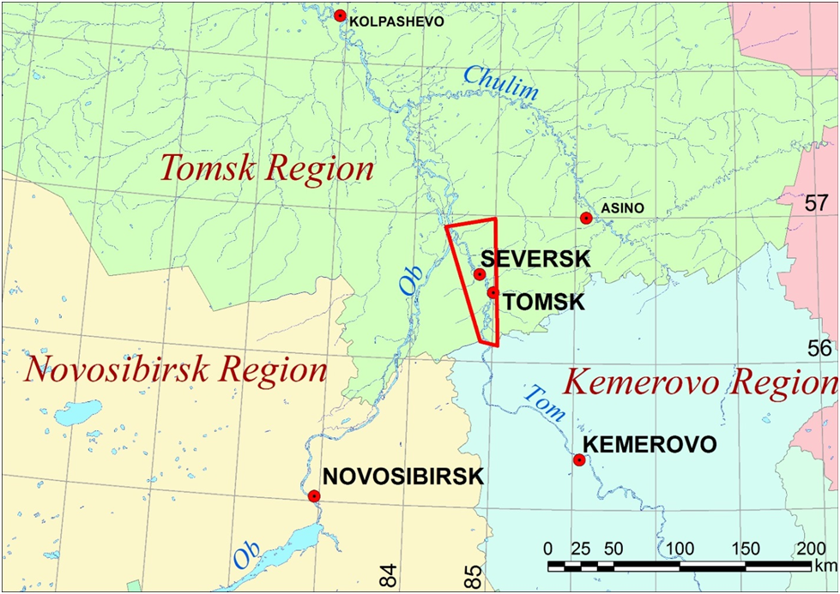
Figure 1 – General map of the study site (red frame)

We will grateful for the dissemination of this information among colleagues!

